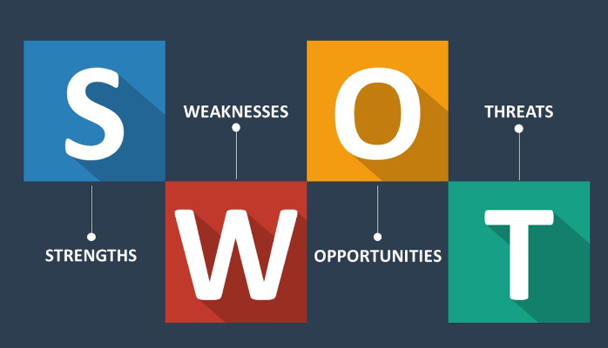

Use the following questions to support you in conducting a self SWOT analysis:

**Strengths (don’t be modest):**

* How do your education, skills, talents, certifications, and connections / networks set you apart from your peers?
* What would your boss or coworkers say are your strengths?
* What resources do you have at your disposal?
* What contributed the most to your past victories?
* What values or ethics do you have that your peers often lack?
* What achievements are you most proud of?

**Weaknesses (be honest):**

* Where are your education, training, or skills lacking? What’s missing and needs improvement?
* What would your boss or coworkers say are your weaknesses or areas of improvement?
* What are your negative work habits and personality traits?  
   What do you avoid because you lack confidence?

**Opportunities:**

* Which opportunities are you not exploiting at the moment?
* What trends are affecting your industry – the industry you belong to or wish to be in?
* In what areas is your industry growing?
* How could new technology help you advance?
* How could your connections and networks help you?

**Threats:**

* What obstacles do you currently face in your career and life?
* Who is your competition?
* Will new technology or certifications demands slow your progress in achieving your goals?
* How is your job or industry changing in ways that could affect your advancement?

S.W.O.T

|  |  |
| --- | --- |
| Strengths   * Being morally upright and having self control and self esteem makes outstanding among my peers. * Being able to attend a code hive class and being in tourism industry makes stand out from my peers. * Iam proud of being able to participate In SGBV eradication education that made me taught many girls in our community how end SGBV. * My hardwork and commitment has contributed to my past victories. | Weaknesses   * In my education i lack daily practise that makes me not to be outstanding in what i do ,and the skills actually have no one to encourage me that actually Esther you can do this. * I procastinate alot that’s makes me not to be able to do a lot of things the i expect them. * Being too emotional. |
| Opportunities   * The opportunities iam not exploiting now is not having time with my family ,friends and relatives. * In the tech theirs is competition globally and in tourism industry ;poaching of animals insecurity and Insufficient funds * The tech industry grows through innovations and coming up with new ideas to solve peoples daily problems. * The new technology helps come up with new ideas especially in the tourism industry. | Threats   * In my life there is no one to guide me so everything seem so difficult . * Technology changes everyday its my fear by the time i will be done everything will be new which may inhibit me from achieving my goals. |